Supplementary file
Case 1:
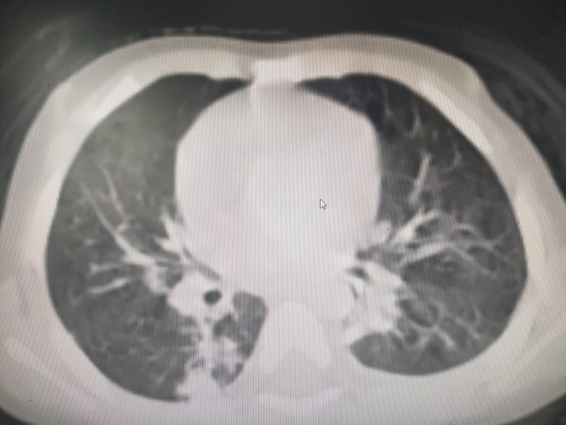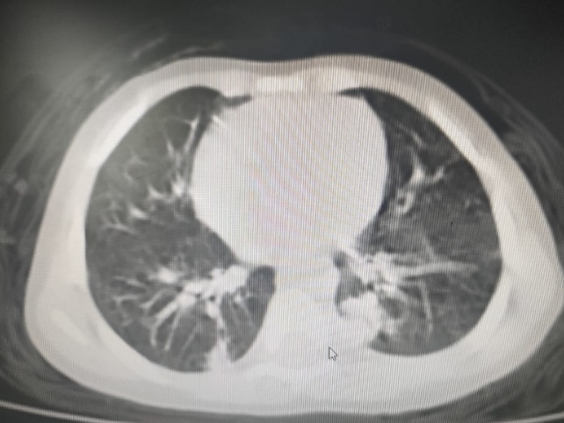
A 30-year-old male patient with anterior segments of the bilateral lower lung lobes showed consolidation with mild interlobar thickening and GGO, suggesting bronchopneumonia.
Case 2
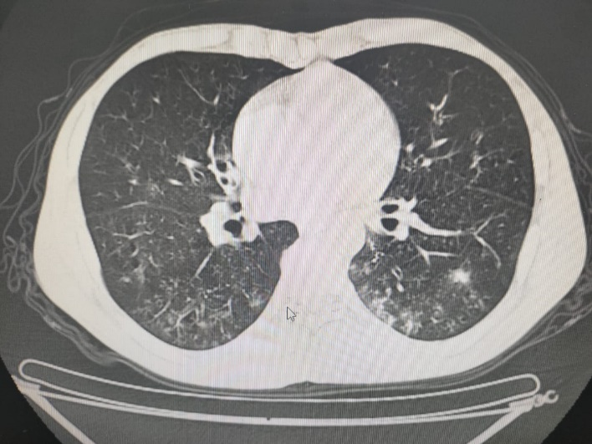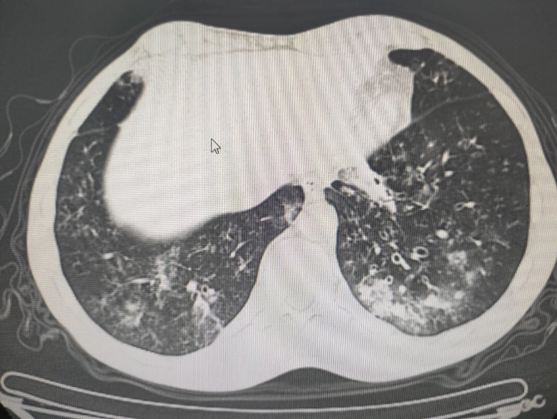
A male patient, 42 years old, with bilateral lower lung lobes, showed GGO with tree-in-bud consolidation suggesting bronchopneumonia (viral pneumonia) COVID-19, CORADS 3, mild severity score.

Case 3
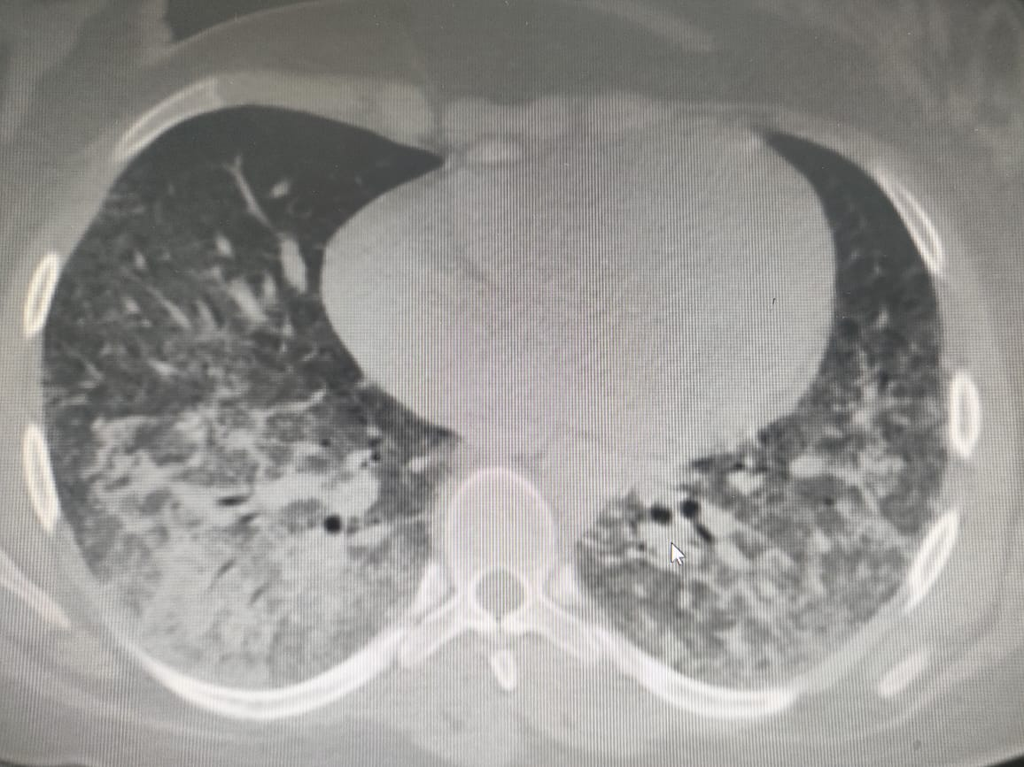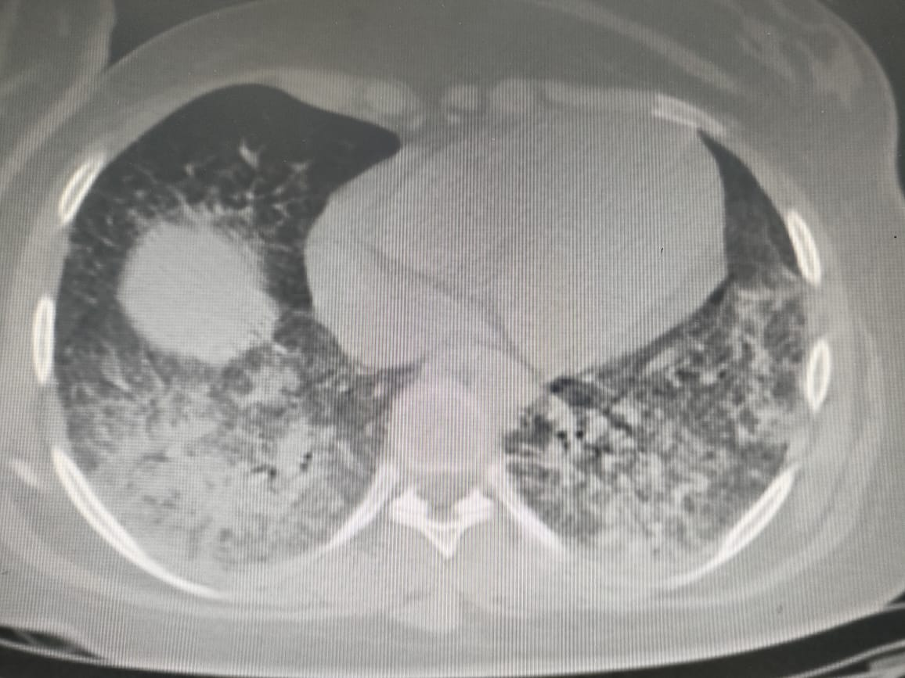
A female patient 20 years with bilateral GGO exhibited mild inhomogeneous consolidation involving both lower lung lobes, suggesting bronchopneumonia

