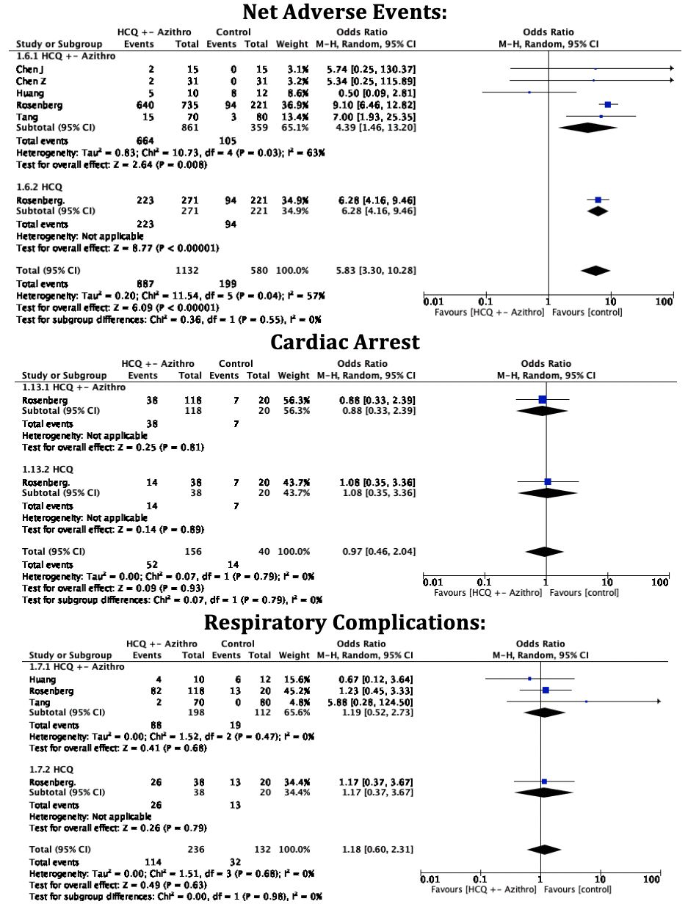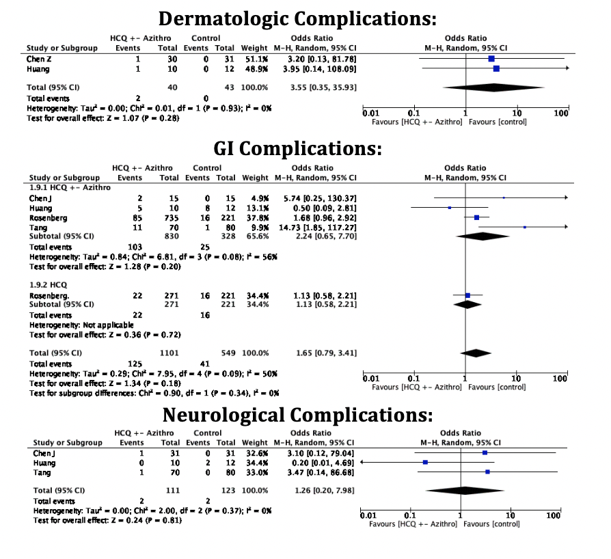

S. Figure 3: Forest Plot for a. net adverse events, respiratory complications, and cardiac arrest (Left side); dermatologic complications, GI complications, and neurological complications (right side) showing an individual and pooled OR for all-studies comparing HCQ treated patients with control.

