Appendix
Appendix Table 1. Mini Z Survey
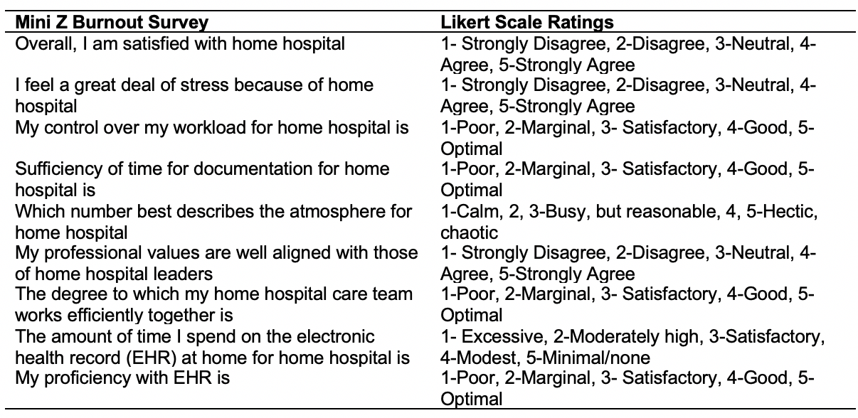
Adapted for Home Hospital Staff with Likert Scale Rating options served as the primary outcome for this study.

Appendix Table 2. Team Evaluation and Program Evaluation Questionnaire
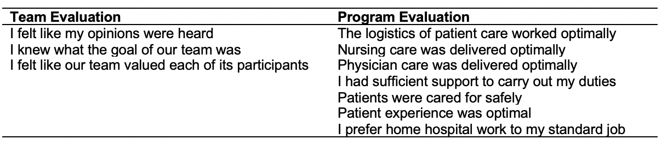
Developed for Home Hospital Staff. Staff were asked to rate their agreement with the above statements on the following scale: 1- Not at all, 2-Slightly, 3-Moderately, 4-Very Much, 5- Entirely.

