Supplemental Table 1 – Standard Reporting System Template
for Potentially High-Risk Patients During Handoff Procedure

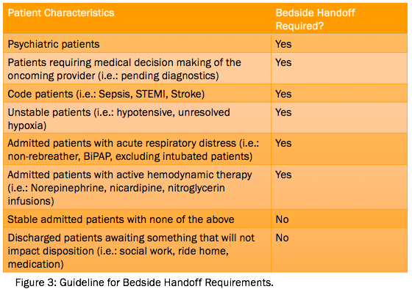

Sample Template:
 | Situation | Background | Assessment | Recommendation
Patient ID (1)
Patient ID (2)
Patient ID (3)
Patient ID (4)
Patient ID (5)

Handoff expectations include a discussion of the above issues in the format of current Situations and Backgrounds of the patients, current Assessments of the patients, and Recommendations for planned or potential courses of care. For the patients listed above, the process is expected to include oncoming and outgoing provider bedside rounds at the time of handoff via use of this SBAR template as a model for discussions among providers.

